**Adoption and Special Guardianship Leadership Board**

**Headline Measures: Q4 2020/21**

**September 2021**

Note: The Department for Education’s annual figures on adoptions and timeliness for children who have been adopted are published in the [Children looked after in England including adoption](https://www.gov.uk/government/statistics/children-looked-after-in-england-including-adoption-2019-to-2020) SFR. This is the most robust source of information on adoption.

**CHILDREN**

The number of children moving into and through the adoption process continued to decline, and those children who already have a best interest decision are waiting longer for permanence. There continues to be a decline in the number of Agency Decision Maker decisions (ADMs) and Placement Orders (POs), and an increase in the number of reversals of ADMs (reversals) being made.

In 2020/21 there were:

* **3730** Agency Decision Maker decisions, an increase of **1% *(30n)***, *(comparison with the published figure in 903SFR 2020)* or a decrease of **7% *(280n)*,** *(comparison with the ASGLB published figure 2019/20)*
* **2910** Placement Orders granted, a decrease of **9% *(280n)*** from 2019/20
* **960** Reversals of the Agency Decision Maker Decision, an increase of **20% *(160n)*** from 2019/20

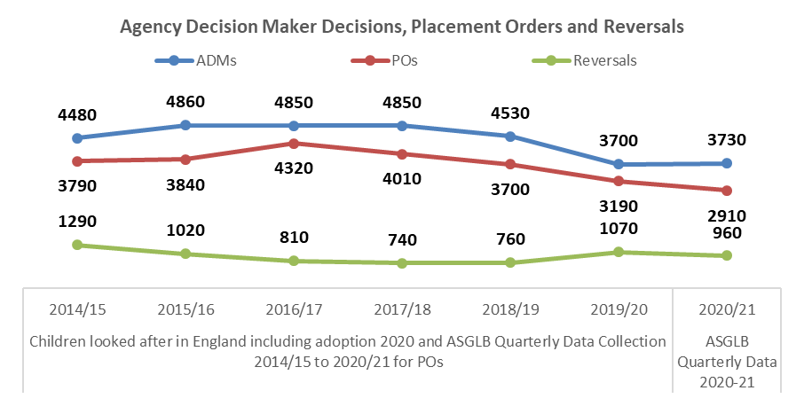

The number of Adoption Orders (AOs) granted continued to decline and the number of Special Guardianship Orders (SGOs) granted continued to increase.In 2020/21 there were:

* **2860** Adoption Orders granted, a decrease of **17% *(580n)*** from 2019/20
* **3840** Special Guardianship Orders granted, an increase of **4% *(140n)*** from 2019/20
* In total there were **6700** permanence orders (AOs and SGO), a decrease of **6% *(440n)*** from 2019/20
* **450** FFA/CP placements, an increase of **15% *(60n)*** from 2019/20

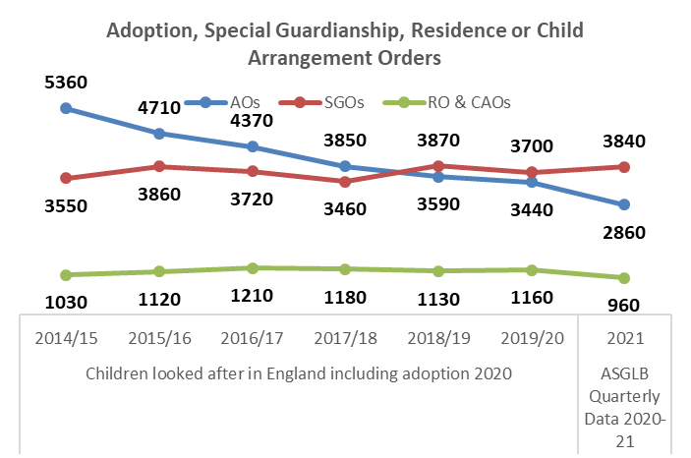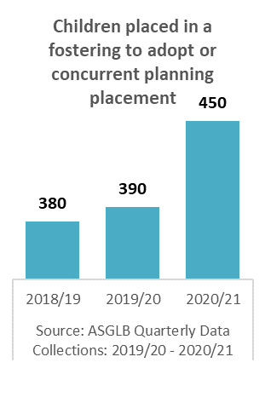

For the last three years there have been more SGOs granted than AOs granted with SGOs accounting for **57%** of permanence orders, an increase from **55%** in 2019/20

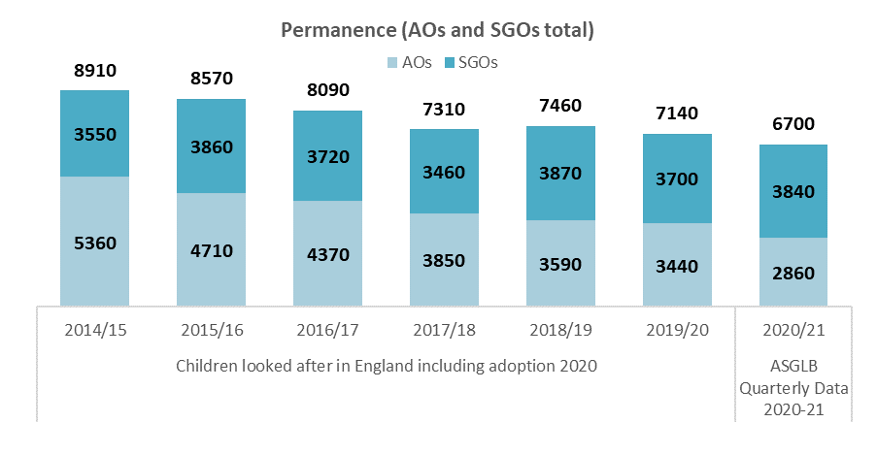

There has been a decrease in the number of children waiting with a PO, however, the number of children waiting with a PO 18+ months increased; 50% of all children waiting with a PO have been waiting 18+ months. In 2020/21 there were:

* **2100** Children with a PO waiting to be matched, a decrease of **14% *(340n)*** from 2019/20
* **1050** Children with a PO waiting to be matched 18+ months, a decrease of **10% *(120n)*** from 2019/20
* **50%** of children with a PO have been waiting to be matched 18+ months, an increase of **2** percentage points from 2019/20

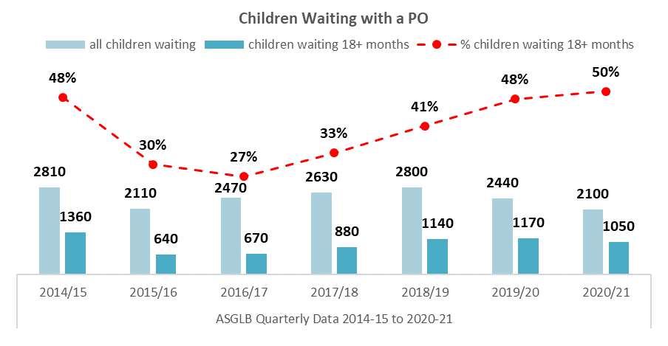

The decrease in the number of children waiting with a PO can be attributed to the continued decrease in ADMS and POs granted in 2019/20 rather than more children finding permanence, as there continues to be a decrease in the number of children matched and placed with adoptive families.

In 2020/21 there were:

* **3050** Children matched with an adoptive family, a decrease of **4% *(140n)*** from 2019/20
* **3060** Children placed with an adoptive family, a decrease of **6% *(180n)*** from 2019/20

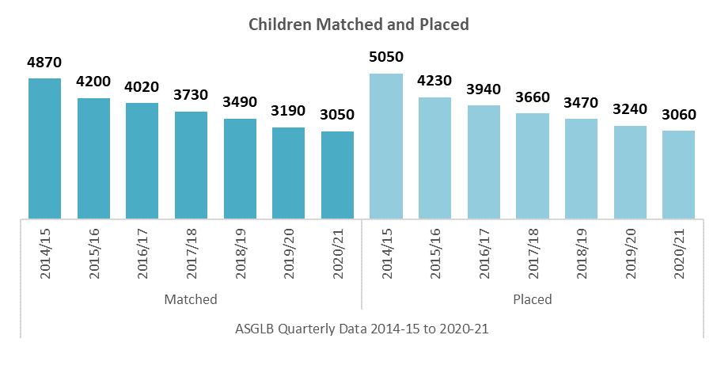

Timeliness for children is increasing with children waiting longer for permanence. In 2020/21:

* The average number of days spent waiting to be placed with placement order since entering care was **645** days, an increase of ***33*** days from 2019/20
* Scorecard Indicator A1 (*average number of days between a child entering care and moving in with its adoptive family*) was ***494*** days, an increase of ***34*** days from 2019/20

NB: A1 measure has been replaced with A10 and will be reported from Q1 2021/22

* Scorecard Indicator A2 (average time between an LA receiving court authority to place a child and deciding on a match to an adoptive family) was **206** days, an increase of ***16*** days from 2019/20

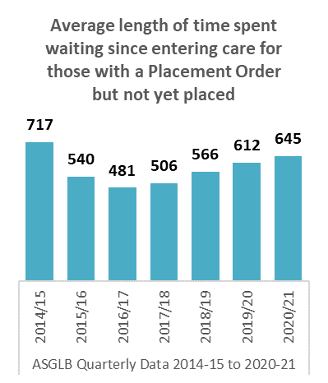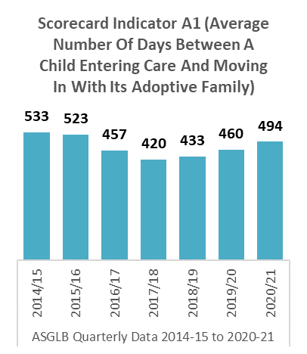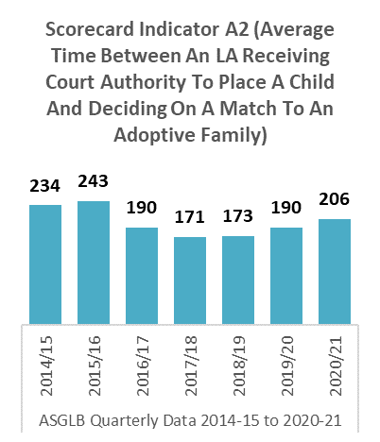

There has been a decrease in the number of children with harder to place (HTP) characteristics waiting with a PO, and waiting with a PO 18+ months. However, these decreases can also be attributed to the decrease in POs granted in 2019/20 rather than more children with HTP characteristics being matched and placed with an adoptive family. Although there has been a decrease in the number of children with harder to place characteristics adopted, **48%** of all children adopted had a HTP characteristic, an increase of **1%** from 2019/20.

In 2020/21 there were:

* **1360** children with HTP characteristics adopted, a decrease of **17% *(2700n)*** from 2019/20
* **1340** children with HTP characteristics waiting with a PO, a decrease of **16% *(260n)*** from 2019/20
* **780** children with HTP characteristics waiting with a PO 18+ months, a decrease of **15% *(140n)*** from 2019/20

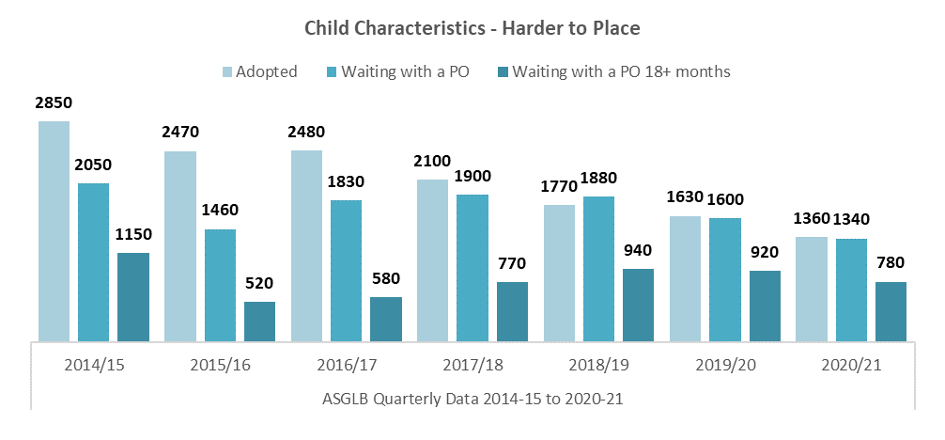

In 2020/21:

* **48%** of all children adopted had HTP characteristics, an increase of **1%** from 2019/20
* **64%** of all children waiting with a PO had HTP characteristics, a decrease of **2%** from 2019/20
* **74%** of all children waiting with a PO 18+ months had HTP characteristics, a decrease of **5%** from 2019/20

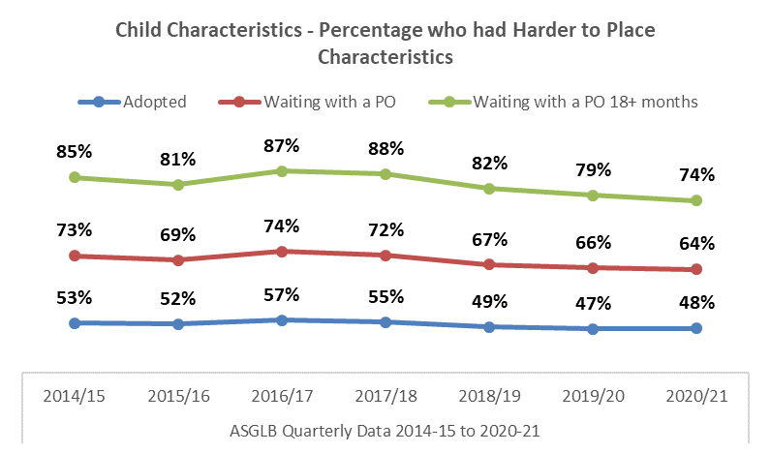

**SPECIAL GUARDIANSHIP ORDERS**

Data for Special Guardianship Orders is collected at aggregate-level for all Local Authorities on a quarterly basis. In 2020/21 there were **3840** Special Guardianship Orders granted, an increase of **4% *(140n)*** from 2019/20.

* **51%** (***1940n***) of the children were male, **49% *(1880n)*** were female *(0.5% (20n) gender not specified)*
* **49%** (***1900n***)SGOs were granted for children under 5 years
* **16%** (***630n***)SGOs were granted from children with an Ethnic Minority (excludes White minorities) background
* **46%** (***1750n***)children were in a sibling group of two or more

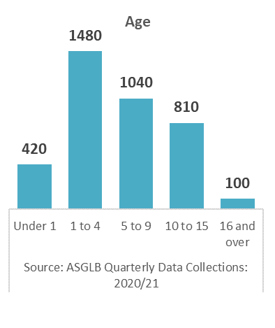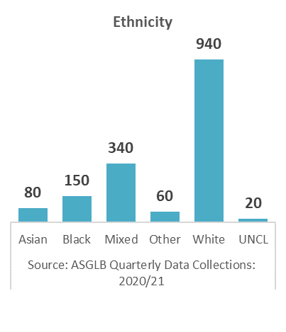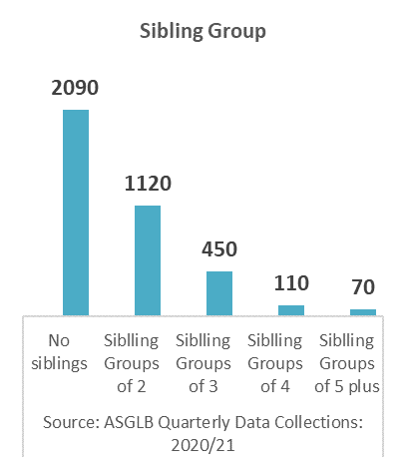

* **53%** (**2020*n***)children were placed with grandparents
* **38% *1450n)*** of special guardians were in the age range 50 to 59

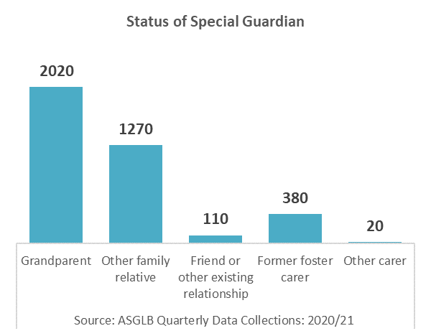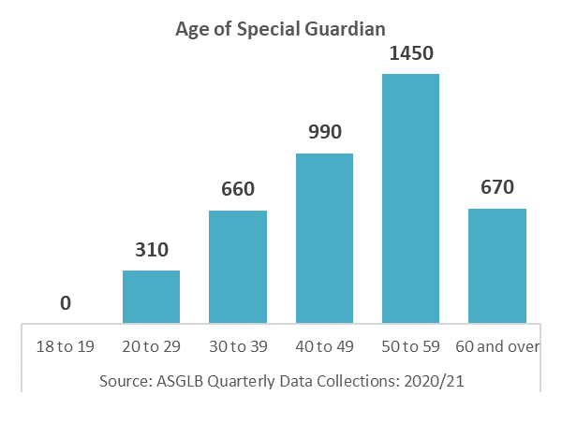

*NB: 2020/21 is the first year that robust quarterly data is being collected for SGOs*

*Please not some figures may not add to the total due to rounding*

**ADOPTERS**

The number of adoptive families has increased. There has been an increase in the number of adopter registrations and approvals, prospective adopters not yet approved and approved adopters waiting to be matched with a child. The increased availability of adopters can be attributed to both the increase in adopter registrations and the steady rate of approvals as well as the decrease in the number of children being matched and placed with adoptive families. In 2020/21 there were a total of:

* **4760** Registrations, an increase of **21% *(840n)*** from 2019/20
* **3130** Approvals, an increase of **6% *(190n)*** from 2019/20

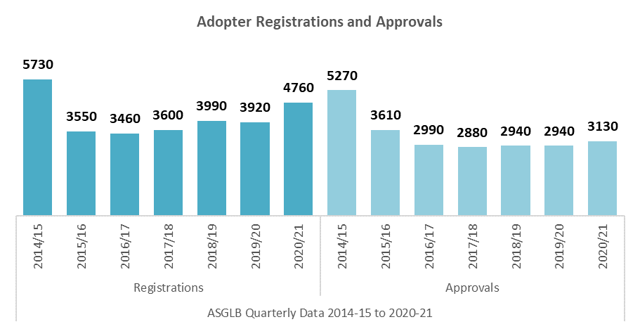

There have been increases in both the number of adopters not yet approved and the number of approved adopters waiting to be matched with a child. In 2020/21 there were a total of:

* **3150** Prospective adoptive families not yet approved, an increase of **20% *(530n)*** from 2019/20
* **2220** Approved adoptive families waiting to be matched, a decrease of **22% *(400n)*** from 2019/20

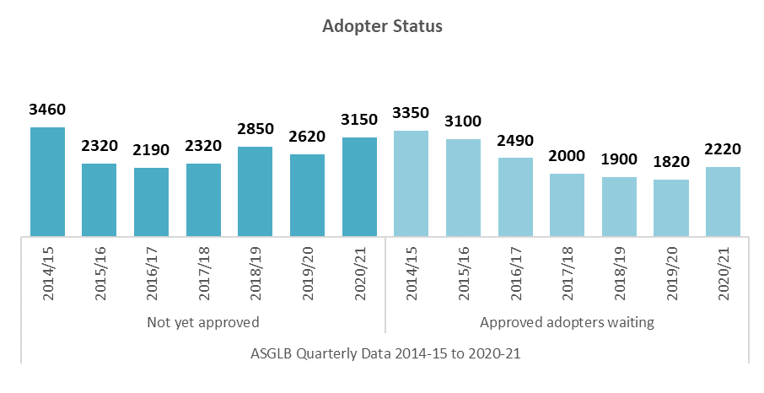

There continues to be a decline in both the number of adoptive families matched with a child, and the number of adoptive families with a child placed with them, which reflects the trends in the decrease in the number of ADMs and POs granted.In 2020/21there were a total of:

* **2550** Adoptive families matched to children, a decrease of **.4% *(10n)*** from 2019/20
* **2470** Adoptive families with a child placed, a decrease of **4% *(100n)*** from 2019/20

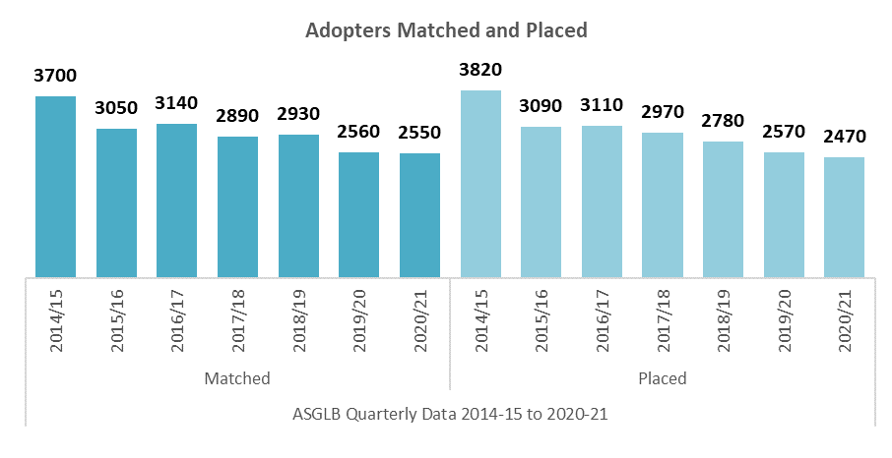

Timeliness for adoptive family approvals have remained stable but the timeliness for adoptive families being matched continues to decline.

* **29%** of adoptive families were approved within 6 months of registration
* **27%** of approved adoptive families had a child matched with them within 3 months of approval, a decline of **5%** from 2019/20

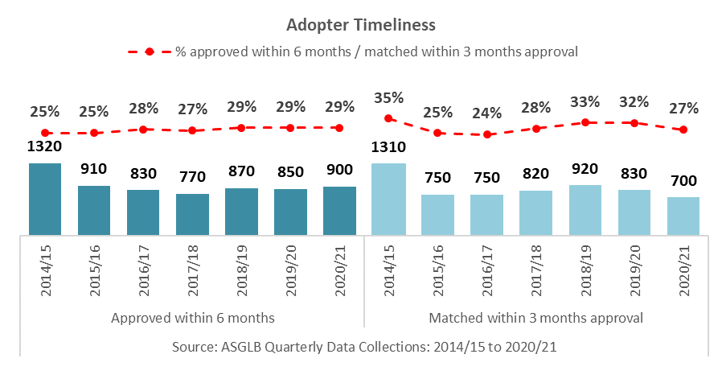

**DATA SOURCES**

**ASGLB Quarterly Data Collection**

In quarter 4 2020/21 the response rate from local authorities for the child level section was 100% and the adopter level sections was 100%. The response rate for the adopter level section from Voluntary Adoption Agencies was 100%. Therefore, national and regional figures on adoptions and adopters do not include estimates made for non-responses.

**SSDA 903 Data Collection**

Local authorities provide data on their looked after children using the SSDA903 collection. Data are collected from all local authorities. The information is collected at child level and includes information about the child’s characteristics and their dates for each stage of the care process, including adoption. The data goes through thorough quality assurance and local authorities are able to update their historic data annually. We therefore view this as the most robust source of information on adoption. It is used to produce the [Children looked after in England including adoption](https://www.gov.uk/government/statistics/children-looked-after-in-england-including-adoption-2019-to-2020) (SFR) and the [Adoption Scorecards](https://www.gov.uk/government/publications/adoption-scorecards). The most recent data covers the year ending 31 March 2020.

**Ofsted Data**

Ofsted have previously published annual data on the recruitment of adopters and the children placed with them. From quarter 4 2014-15 the Ofsted data collection became part of the quarterly survey.

**ABOUT THIS PUBLICATION**

This publication was produced by The Children and Social Care Secretariat, delivered by Coram-i on behalf of the Department for Education.

download: [ASGLB Quarterly Data](https://coram-i.org.uk/asglb/data/)

email: [asglb@coram.org.uk](mailto:asglb@coram.org.uk)

visit: [Adoption and Special Guardianship Leadership Board](https://coram-i.org.uk/asglb/)

write: Coram-i, Coram Campus, 41 Brunswick Square, London WC1N 1AZ