EXODUS: information about the research for young people

The Coram team would like young people aged 11 to 17 to take part in our research. Before young people decide if they are happy to take part, they should read this information. It explains the research we are doing and what we need young people to do.

Please **get in touch** if you have any questions at all. You can contact the lead researcher, Hannah Lawrence, by:

* 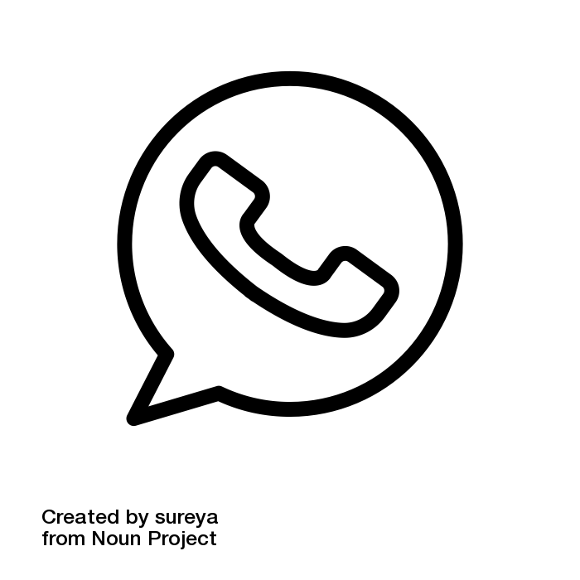 calling, texting or sending a WhatsApp message to 07805 813071
* calling 020 7520 0365 (Monday to Friday from 9am to 5pm)
* emailing [research@coram.org.uk](mailto:research@coram.org.uk)
* writing to Coram Impact & Evaluation, 41 Brunswick Square WC1N 1AZ
* you can find out more about Coram here: [www.coram.org.uk](http://www.coram.org.uk/what-we-do/our-work-and-impact/coram-centre-for-impact-and-evaluation)

# What is EXODUS?

* EXODUS is a **mentoring programme** for 11 to 17 year olds who are at risk of offending.
* EXODUS aims to reduce the likelihood of young people offending
* Mentors who understand the criminal justice system take young people through a structured mentoring programme.



UpskillU run EXODUS. You can find out more about UpskillU here: <https://upskillu.co.uk>

The Youth Endowment Fund funds EXODUS and this research. More information here: <https://youthendowmentfund.org.uk>

# What is the research?

Coram is a charity that aims to help young people. Coram’s research team is working with UpskillU to research the impact of EXODUS on young people. As part of the research, young people taking part will be **randomised**. This means about 50% of young people will randomly get EXODUS, and 50% will randomly get the normal support offered by their local youth offending service or local council.

At the end of the research, Coram will compare the outcomes for the young people that got EXODUS to the young people that got usual support. We will then look if EXODUS can help achieve positive outcomes for young people, including reducing offending. At the moment, we do not know if EXODUS works so this research is very important.

If you agree to take part, you will be randomly put into the EXODUS group **or** the normal support offered by your local youth offending service or local council. We will work with you while you get either type of support.

# Why do you want me to take part?

We want you to take part because you have been involved in your local youth offending service or a service run by your local council. It is really important that we get a lot of young people involved in the research to see any results - **we need at least 800 young people to take part** across the country!

# What happens if I agree to take part?

If you are happy to take part, you will need to complete a **consent form** (at the end of this information). After that, a researcher will support you to answer some questions using an online questionnaire. The questionnaire asks about any offending you have been involved with in the past year and how you have been feeling and behaving over the last six months. The researcher will contact you again three, six and 12 months later. At six and 12 months, the researcher will ask you to complete the online questionnaires again. **You will receive a £10 thank you voucher for completing the questionnaires at six months and then another £10 voucher at 12 months.Will what I have said be shared with other people?**

Your answers will be analysed with other answers from young people by the Coram research team. Your answers **will not be shared** with any other teams, such as your local youth offending service. Your answers will not affect any support you receive. The only time the researcher or person at Coram would break confidentiality is if you said something to them which suggests that someone is at risk of harm. For example, this could be if anyone is going to be attacked. In the rare occasion this might happen, the researcher would talk to you about how and when they are going to share this information with others.

# Could it be upsetting for me to take part?

As the questionnaire asks about any offending you have been involved with in the past year and how you have been behaving and feeling over the past six months it may feel sensitive. You do not need to answer any questions if you find them upsetting, and you can take a break or stop at any time. We aim to be **supportive and kind** and 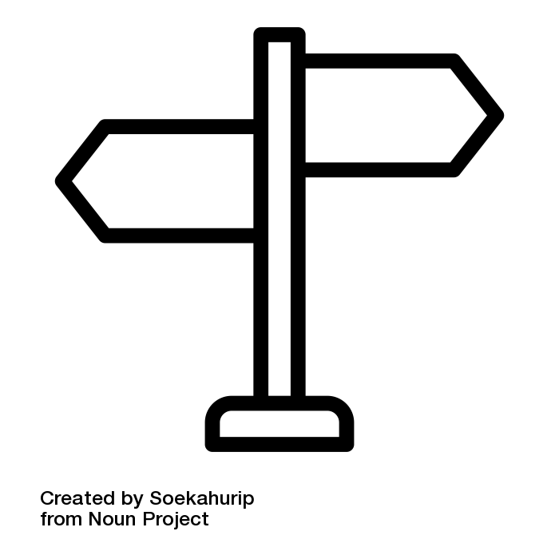we will **signpost you to support** if you need.

You may feel disappointed if you are not offered EXODUS, this is completely understandable. Whether you are offered EXODUS is completely down to **chance** and in no way due to anything you have said or done. Whether you are or are not offered EXODUS, the researcher and your youth offending worker (or similar) will talk about the other support available to you. Remember at this stage, we do not know that EXODUS helps young people more than the regular support services available.

# What will happen to the results of the research?

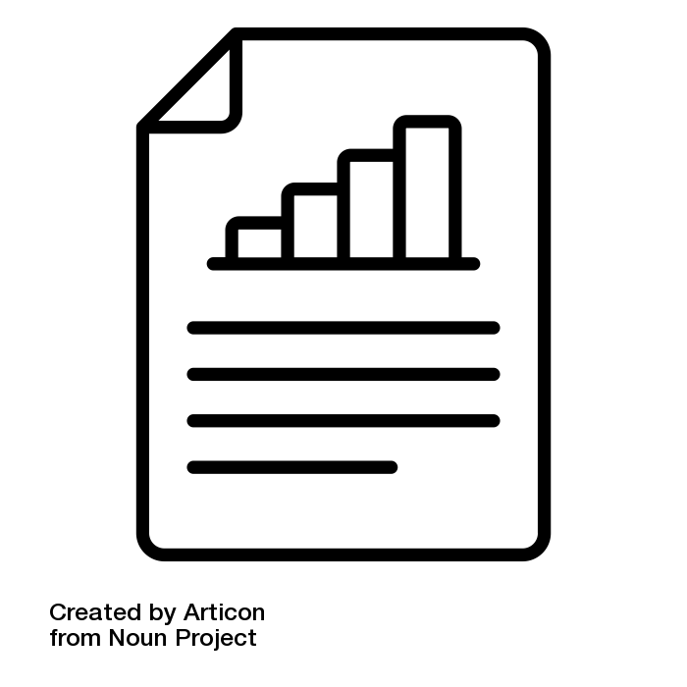We will write a report about the research in March 2025 and again in 2028. We can share the report with you if you would like. The report will not contain any names or anything which could identify you. The report will be published on the Youth Endowment Fund’s website and possibly in an academic journal.

At the end of the research the Youth Endowment Fund will **archive some of your data** (your name, gender and date of birth). The Youth Endowment Fund wants to know whether taking part in the research study prevents young people from being involved in crime and violence as they grow older. To do this, the Youth Endowment Fund will keep information about the young people who have taken part in this research in an archive. Once this data is transferred it will be **permanently deleted** from Coram’s data storage systems. When your data is archived by the Youth Endowment Fun your name will be removed. From this point on, it will no longer be possible to identify you from the data. More information about this is in our **data privacy notice** here: www.coram.org.uk/wp-content/uploads/2024/04/EXODUS-research_data-privacy-notice-Apr-2024.pdf

# Do I have to take part?

No. It is up to you whether you take part – either way this will not affect any support you receive from your local youth offending service or local council now or in the future. If you agree to take part today then you can change your mind later. You can decide to withdraw from the research at any point up until **31 December 2024**. To do this please contact Hannah Lawrence at Coram on the same contact details (above).

# How will you use the information about me and how will you keep it safe?

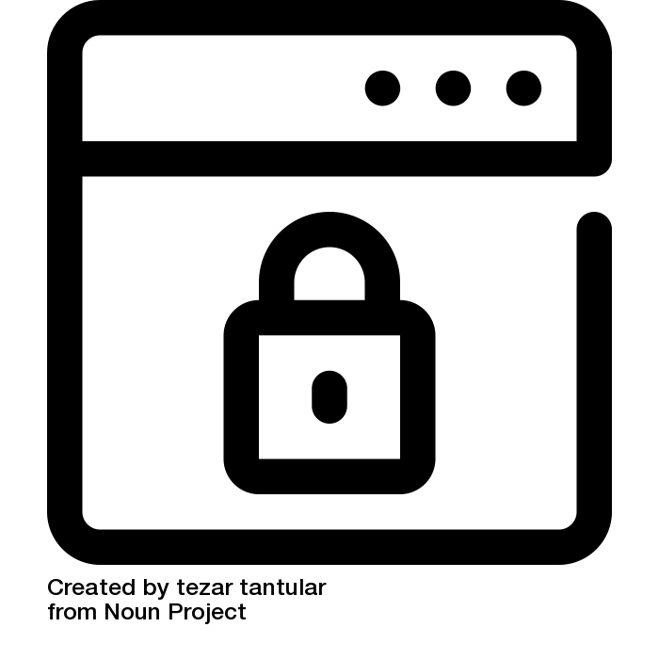We have many systems to keep your data safe.

Here is our **data privacy notice**: [www.coram.org.uk/wp-content/uploads/2024/04/EXODUS-research_data-privacy-notice-Apr-2024.pdf](http://www.coram.org.uk/wp-content/uploads/2024/04/EXODUS-research_data-privacy-notice-Apr-2024.pdf)

It is quite long, but it explains everything you need to know about how we make sure we keep your data secure. Please do take the time to read it and get in touch with us if you have any questions at all.

# I am happy to take part, what do I need to do?

You will need to complete the consent form on the next page.

**Thank you for taking the time to read this information and we hope that you will take part in the research!**

Consent form to take part in the EXODUS research

**Please tick the yes or the no box for each statement:**

|  |  |
| --- | --- |
| I have read the information about the EXODUS research or someone has read it to me | **Yes No** |
|  |
| I have been able to ask questions about the information about the EXODUS research and I understand it |  |
| I am happy to be randomised either into EXODUS or for business-as-usual support as part of the EXODUS research |  |
| I agree that the information collected (what I say) will be used in a published report and may be talked about at events anonymously |  |
| I understand that my information (what I say) will be stored securely |  |
| I understand that information I provide will be confidential unless the researcher has concerns about my or another person’s safety. If this happens, the information will be passed on to the relevant people |  |
| I understand that my data will be transferred to a data archive and kept indefinitely |  |

**Your name:**

**Your signature:**

**Today’s date:**